Attachment B – Urban Design Guideline assessment
This assessment considers all proposed lots against the Link Road North Precinct Area Plan, except Lot 4003.
Lot 4003 is located in the Minmi Extension Precinct and is proposed as a future development lot where controls under the UDG are not relevant to the works proposed.
Part 2 Subdivision Design and Layout
1 | Subdivision of the Link Road North Precinct should be undertaken generally in accordance with the lot layout and access plans illustrated in Figure 2 and Figure 3.  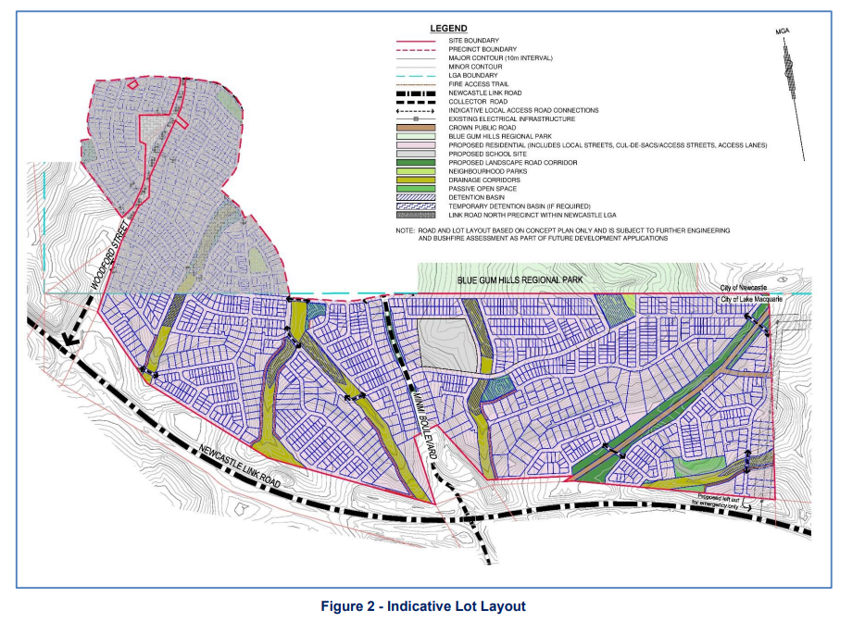  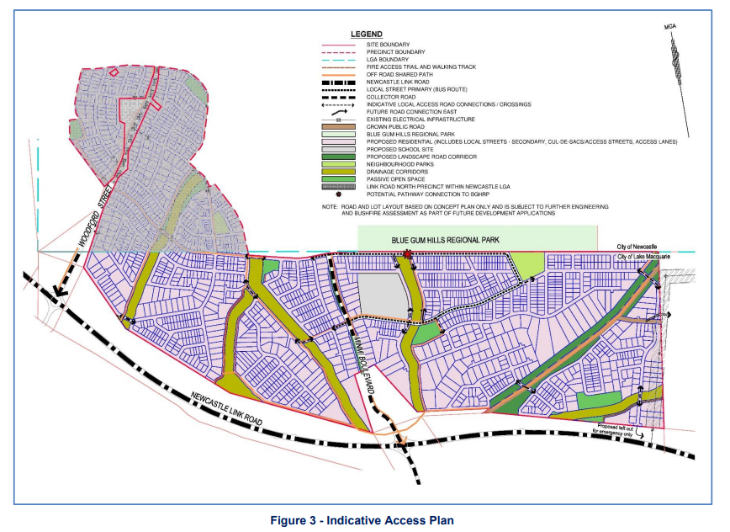 | The development application proposes a lot layout that is generally consistent with the lot layout and accesses included in the Area Plan.
2 | Roads shall be designed generally in accordance with the width requirements as detailed in Table 1 and Figure 4, and having regard to the road types as nominated by the Access Plan (Figure 3).  Exceptions to the width and configuration of Minmi Boulevard may be acceptable where a feature entry road is proposed, for example the indicative cross-section shown in Figure 5.  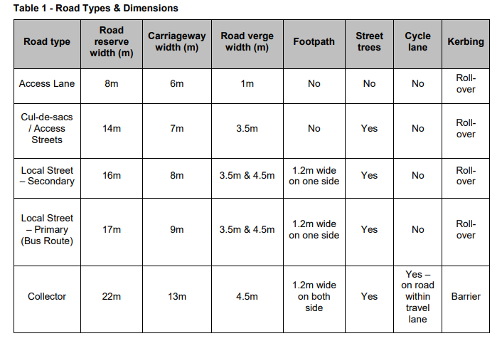  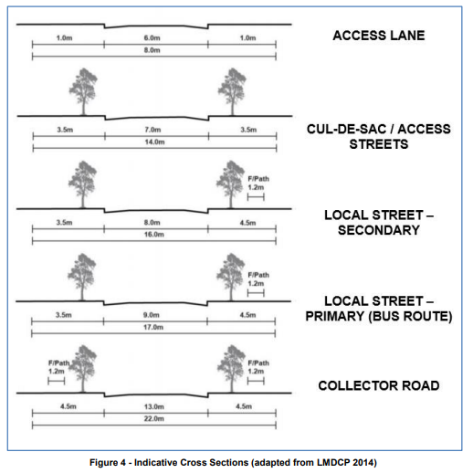 | For all local streets within the development, a 16m road reserve and including 8m wide carriageway has been proposed, which is consistent with the Area Plan.  The development includes two collector roads, as shown in the figure below in pink. The collector roads have a 23m road reserve and 13m wide carriageway. The wider road reserve accommodates for a 2.5m wide shared path.  Minmi Boulevard, shown in the figure below in purple is a sub-arterial road. The UDG does not prescribe details for sub-arterial roads. Minmi Boulevard proposes a 24.6m road reserve, a central 3m wide median, a 5.8m wide travel lane in each direction to cater for vehicles and on road cycle lanes, and an off road shared pathway. This is suitable.  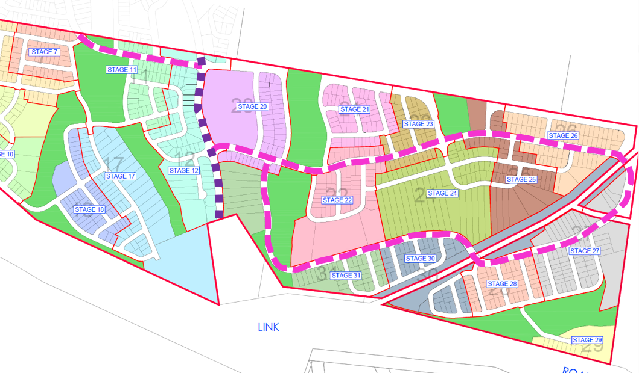
3 | Public roads may be designed with maximum grades of 12.5% for designated bus routes, or maximum 16% for all other road types. Split level carriageways may also be used to address significant topographic constraints. | The grade of roads throughout the development is generally 10% of less.  Only one local road MC 94 adjoining the public reserve exceeds the maximum grade being 18%. This has been reviewed and is acceptable as it is less than Council’s normal acceptable maximum grade of 20%.  Only one portion of the proposed bus route MC 60 adjoining the public reserve exceeds the maximum grade being 13%. This has been reviewed and is acceptable given the minor exceedance and the steep nature of the site.
4 | Lot types, lot frontage and minimum lot size and depth are to be provided that generally reflect lot size and dimensions as follows:  - Small lots: 7m frontage and minimum lot size 175m²  - Standard lot: 17m frontage and minimum lot size 450m²  An allotment is considered to be a small lot where the lot has an area of less than 450m².  Development consent may only be granted for the creation of a small lot with a frontage of 8m or less where the development application for subdivision includes the erection of an attached dwelling, semi-detached dwelling or a dwelling house.  For small lots, mandatory and optional built to boundary walls are to be nominated on final subdivision plans | The application proposes 113 small lots that have areas of between 300m²- 450m².  All standard residential lots have a minimum area of 450m² or more.  No lots have a frontage less than 12m.
5 | Cut and fill associated with subdivision development should be responsive to the design constraints associated with the site topography noting that significant earthworks will be required to accommodate required subdivision works including roads, drainage, detention basins and utility infrastructure. Cut and fill on proposed lots, including benching, retaining and battering, is permissible where required to achieve land suitable for future residential development, particularly where it reduces the need for significant cut and fill for the construction of dwellings. | Sufficient information to enable detailed assessment of this matter has not been provided.  A request for this information has not been made to the applicant due to the outstanding fundamental site planning and threshold issues. A request for this information can be made following the resolution of these fundamental issues, as it is likely the development can achieve this requirement through existing site design or incorporation of measures such as retaining walls (designed and located appropriately).
6 | The following controls apply to subdivision for the purpose of creating a battle-axe lot:  - A battle-axe lot must have a minimum area of 600m², with a minimum width of 15m.  - A battle-axe lot must have a minimum rectangular building area of 240m² with a minimum width of 12m.  - The minimum width of the battle-axe handle is four metres when servicing one lot, and five metres when servicing two or more lots. The maximum number of Torrens Title battle-axe lots sharing a single access handle is two, provided suitable easements for access and services are provided.  - Small lots cannot be subdivided as battle-axe lots. | Two battle-axe lots are proposed (Lot 1205 and 2912). The lots have areas of 683m² and approximately 1000m², are 15m and 22m wide, are the only lot serviced by the access handle, and can achieve the required building envelope.
7 | Open Space, Neighbourhood Parks, Water Quality Basins, Detention Basins, Shared Paths and footpaths shall be located generally in accordance with Figure 2. | The development application proposes a site layout that is generally consistent with the lot layout and accesses included in the Area Plan.
8 | Location and width of Asset Protection Zones (APZs) and Managed Fuel Zones are to be provided in accordance with Planning for Bushfire Protection 2006. | APZs have been provided in accordance with Planning for Bushfire Protection 2006 and are located within residential lots or road reserves.
9 | The road network, including any proposed fire trails, should be designed having regard to the requirements of Planning for Bushfire Protection 2006. | Roads, including fire trails have been provided in accordance with Planning for Bushfire Protection 2006.
10 | Development applications for subdivision creating residential lots adjoining Woodford Street or proposed Minmi Boulevard must consider the management of acoustic privacy and urban design outcomes. The following principles should be considered:  - Where possible, residential lots should be designed so that future dwellings are oriented to front Minmi Boulevard or Woodford Street;  - Where possible, direct vehicular access from residential lots to Minmi Boulevard should be discouraged. In general, vehicular access should be provided by a service road or rear laneway;  - Where it is not practicable to orient future dwellings to Minmi Boulevard or Woodford Street, suitable fencing shall be provided and appropriate landscaping shall be incorporated into the road reserve to soften potential visual impacts of fencing along these roads. | The development has not been designed for future residents to front Minmi Boulevard or Woodford Street. Further, direct vehicle access to these roads will be restricted through public domain design, site levels or covenants.  Where future dwellings do front Minmi Boulevard or Woodford Street, acoustic attenuation through increased quality glazing will be required. Conditions of consent are recommended to ensure covenants are placed on the affected lots to identify this requirement to future residents.  Fencing to roadways has not been shown on the landscaping plans. A request for this information has not been made to the applicant (however was flagged in a request for information as a future matter to be considered) due to the outstanding fundamental site planning and threshold issues.  If the application is deferred, a request for this information can made following the resolution of these fundamental issues, as landscaping outcomes are reasonable resolvable.

